* **Review the** [**Design Systems website (Links to an external site.)**](https://www.designerlynx.co/design-systems) **then, compile 2-3 paragraphs explaining each feature in greater depth and share at least one example of how that feature can be used in your project. Providing sample code is optional.**
  + **In order to use tools for Material Design, there are several different tools and features that allow you to have an easier flow to your work. First, there are design systems, which are immensely helpful in creating a seamless, integrated environment that allows have a solid color scheme and UI layout throughout your project. Examples of products that are great for Design systems are Microsoft Fluent, IBM, and Atlassian design systems.**
  + **Another particularly important feature is design software. Design software allows users to easily create and manipulate UI elements without having to edit any of the source code itself. This also allows users to visualize their UI elements and create mockups of their final products. Examples of Design software are Figma, Sketch, and Webflow.**
  + **A feature that does not play a huge role in development however it plays a key role in pushing design to public and UI design is icons. Whether the icons are for buttons on a program or for the screen icon on a cell phone, Icons are one of the top features to attract potential customers. Icons like the cog icon for settings, or three lines for options bar, or even icons that are specific to a company like the thought bubble on iPhone is known for messages. Icons are visual representations of a product that allow for consumers to know exactly what they are looking at just by seeing a small picture. Sources to purchase/create icons are Feather Icons, Icon store, and Material Design Icons.**
  + **Another key feature of Material Design would be the Inspiration for your project and where you find your ideas for UI. Inspiration is key to developing a sturdy base idea which your product and Material design will build from. Not having an idea to build off of leads to an empty project with a poor Material Design. Examples of places to gain inspiration for your Design are Site Inspire, Dribbble, Mobbin, and httpster.**
  + **A huge part of any Material design is prototyping. Before creating a main, high fidelity design, a user must have at least one if not many different prototypes of their design to visualize different elements on their project that may or may not work together. Prototyping is also useful for when the user may not have their idea for their design set in stone and want to experiment on feature placement and overall Material Design. Examples of software that allow for prototyping are Ninja Mock, Figma, and Marvel.**
  + **Last, a major factor that plays a key role in a material design is its color scheme. A color scheme is a set of colors that go together to make up the overall visual representation of your product. Like Spotify having Green and Black, or Walmart having Blue, White, and Yellow, a Material Designs color scheme is what allows it to stand out as the final product and what it does. Just looking at a select group of colors, you can usually associate them with a company logo. This is because those companies have used these color schemes to create a memorable representation of their product.**
* **Review other UI/UX design tools available today (at least 5), compare and contrast their main features in support of your project, and present for discussion in a table. A sample portal to find supporting information can be found at** [**22 best UI design tools | Creative Bloq (Links to an external site.)**](https://www.creativebloq.com/how-to/20-best-ui-design-tools)**,** [**UX Tools | Compare Design Systems Tools (Links to an external site.)**](https://uxtools.co/tools/design-systems)**,** [**7 Tools for Building Your Design System in 2021 | by Jonathan Saring | Bits and Pieces (bitsrc.io) (Links to an external site.)**](https://blog.bitsrc.io/7-tools-for-building-your-design-system-in-2020-452d9c9b3b8e)**.**

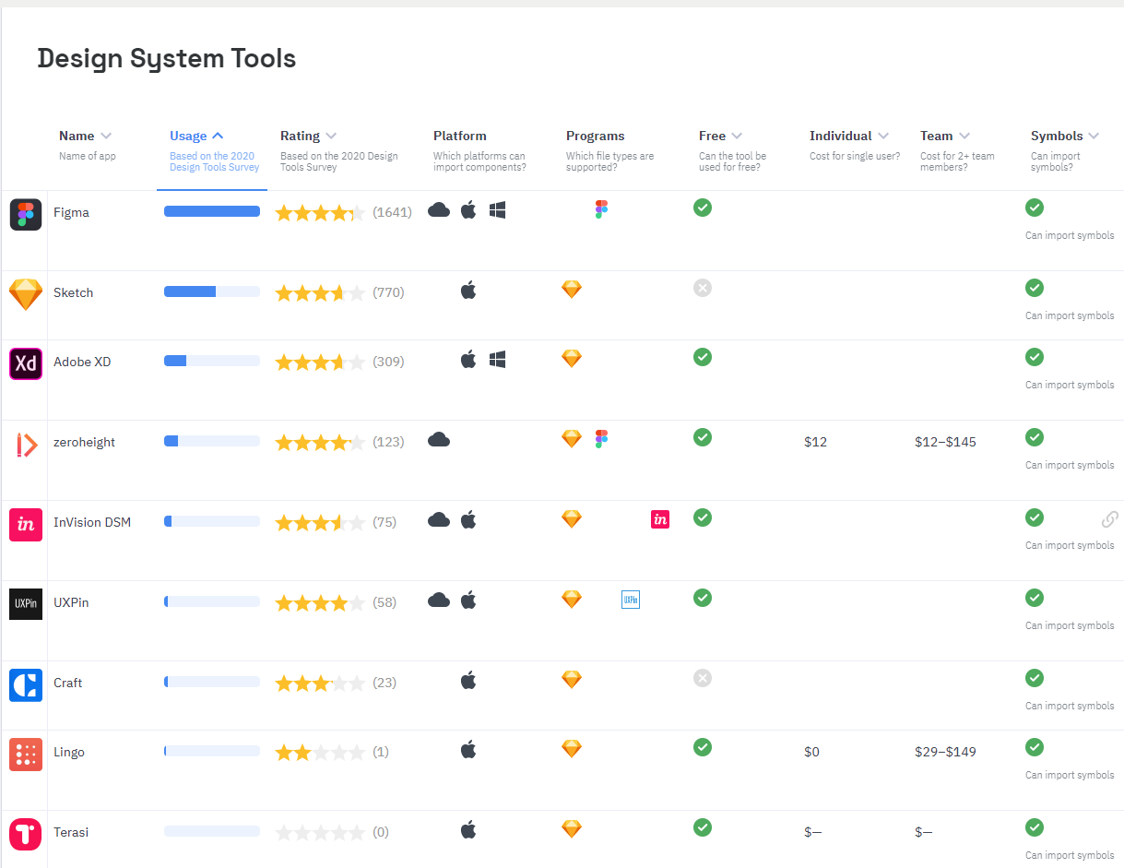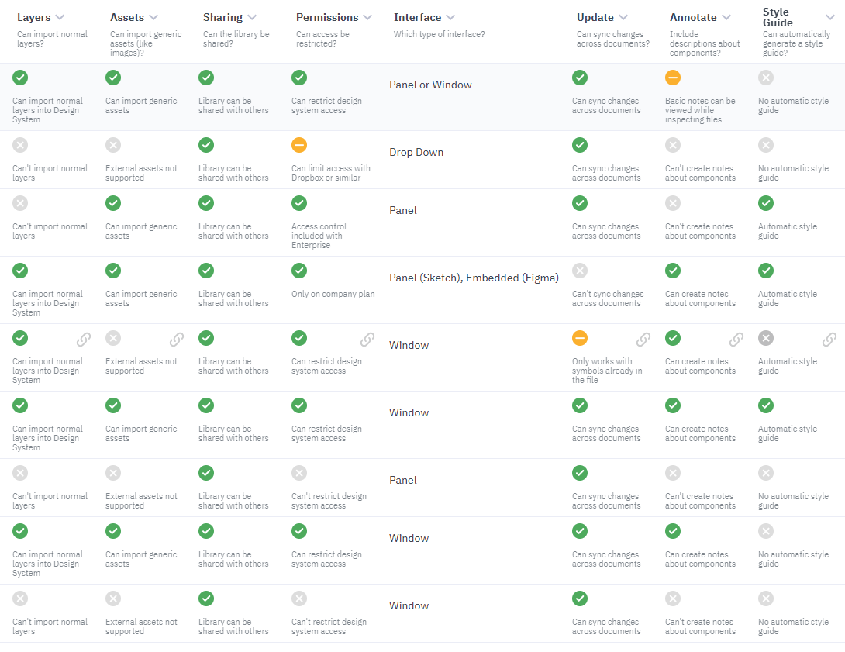

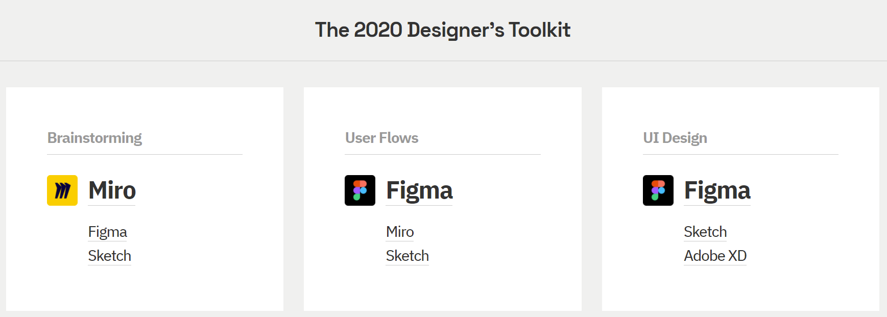

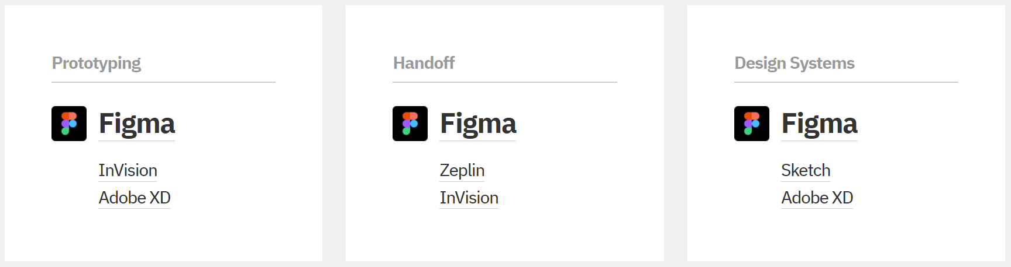

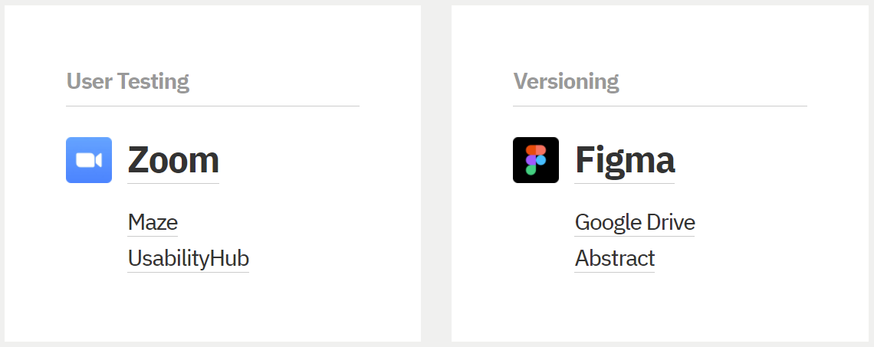

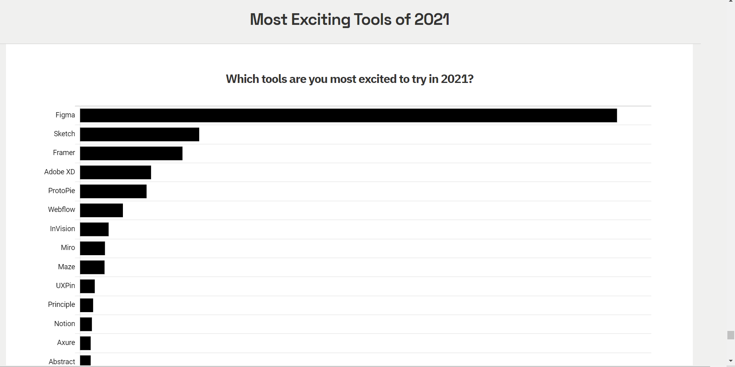

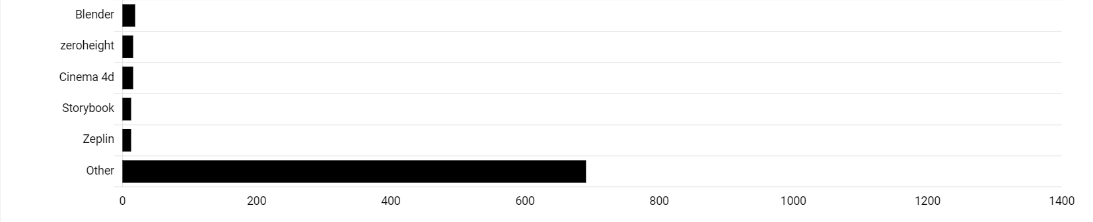

* **Present a plan for next steps to follow to continue improving your ongoing team project for the course.**

**Google Fonts** has a library of thousands of free and open-source fonts families. It also has APIs that allow you to use fonts via CSS and Android.

**Figma** gives users tools that they need for the design phase of their project, including vector tools which are capable of fully-fledged illustration, as well as prototyping capabilities.

**Adobe XD** allows you to create and edit vector files that are easy to scale and optimize for the high-resolution displays used in modern mobile phones and computer monitors. It can also create components that can be used in both web and mobile design.

**UiGradients** is a contributed collection of beautiful multi-color gradients that is free to use on UI or design projects. You can also download the CSS gradient code.

* **References:**
  + The best UI Icon resources. (n.d.). <https://www.designerlynx.co/icons>.
  + *UX Tools: Design Tools Database*. Uxtools.co - Uxtools.co. (n.d.). <https://uxtools.co/tools/design-systems>.
  + Tools, U. X. (n.d.). *2020 Tools Survey Results*. UX Tools. <https://uxtools.co/survey-2020/#toolkit>.